**Software Developer Course Assessment**QAP – 3

**Name:** Justin Greenslade

**Course Name:** Advanced Programming (Java) **Current Week:** 2nd July 2025  
**Submission Deadline:** 12th July 2025

# Instructions (To be included in your submission):

Please answer the following:

1. How many hours did it take you to complete this assessment?  
   [

Roughly 7- 8 hours total

Problem #1: 1.5 – 2 hours

Problem #2: 1.5 - 2 hours

Problem #3: 2-3 hours

Problem #4: 1 hours

]

1. What online resources did you use?  
   [Lectures, Course Notes, Google, W3Schools]
2. Did you get help from any classmates?  
   [Reviewed with Usual group members to compare outputs]
3. Did you ask for help from an instructor?  
   [No]
4. Rate the difficulty of each problem and your confidence in solving similar problems in the future.

[

Problem #1: Difficulty 2/10 Not hard felt straight forward and clear.

Problem #2: Difficulty 3/10 Also felt manageable. The logic made sense and followed naturally from what we have done before.

Problem #3: Difficulty 7/10 The math made me think a little more but still felt confident once I double checking my calculations and outputs.

Problem #4: Difficulty 6/10 Again here the math made me think more however felt easier due to repeating code and added the scaling logic. Once again I felt better after checking my calculations and outputs

]

Problem 1

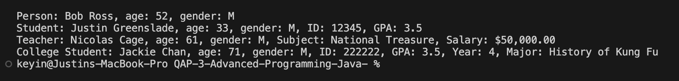

Problem 2

Problem 3

Problem 4

